**Human Machine Interaction**

Module 01 : Foundations of HMI

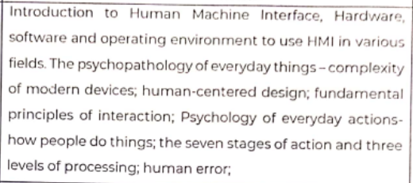

***What are the three levels of processing and seven stages of action? How they are interrelated to each other?***

***Norman’s Model of Interaction. (seven stages of action)***

The three levels of processing is used in usability design. Usability Design is a measure of the interactive user experience associated with a user interface. User interface can be a website or software application. It was suggested by Donald Norman in his book “*The Design of Everyday Things”*

It consists of :

Visceral Level, Behavioural Level, Reflective Level

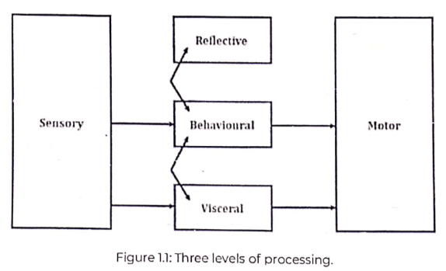

Visceral Level : It is the first level of processing. It involves our most primitive reflexes, like startling at a loud noise or flinching when something flies towards us unexpectedly. The user reacts to audio, visual and other aspects of a product before experiencing it. The look, feel and sound of the product dominates the user in this level.

Behavioral Level : It is the middle level of processing. The emotional brain takes control of the decision making process. The user reacts to the products at a deeper level than that of visceral. It manages simple, everyday actions and the functionality of the product is of prime importance in this level. In behavioral design, semantics and usability practices are primarily addressed.

Reflective Level : It is the last level of processing. A careful analysis and reflection of all the incidents or experiences is made and the meaning of the experience is stored in our brain. It can tell us about customers inclination towards various ranges of products.

*Seven Stages of Actions : GPS-PPIC*

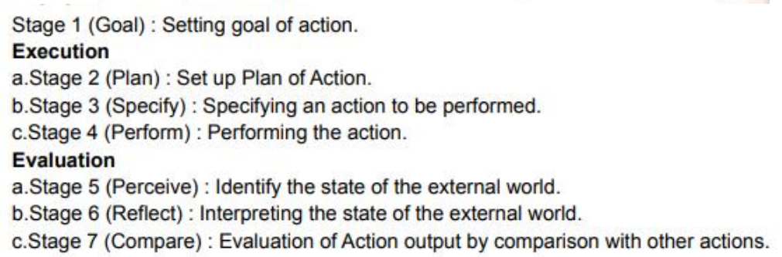Example :

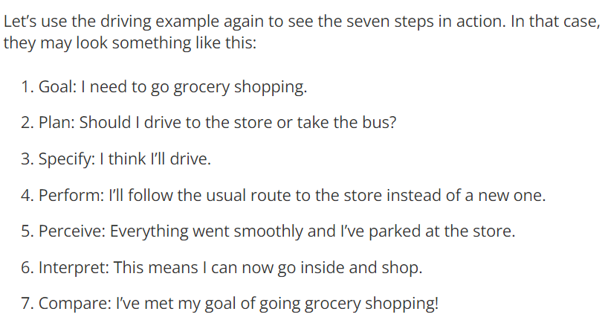

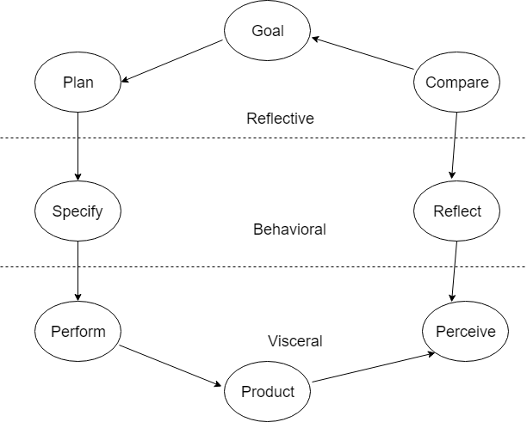

Execution | | Evaluation

*Interrelation of Level of Processing and Stages of Action*

When we interact with a new object, we have two problems to solve: “How do I use this?” and “Did that work?” Author Don Norman calls these “the gulf of execution” and “the gulf of evaluation.”

* The Gulf of Execution : It refers to the process of figuring out what an object does and how to use it. It happens either before using the object or while trying it out. It includes affordances, signifiers, and mapping tools to help users bridge this gulf.
* The Gulf of Evaluation : It occurs after the user has used an object. It refers to the process of evaluating what the device did whether how it performed certain operations using different buttons etc and to check whether that action matched our goals. It includes feedback and mental models for bridging this gulf.

***Human Centric Design :***

* It is a creative approach to problem-solving.
* It is also called User Centric Design approach.
* It designs frameworks that develops solutions to problems by involving the human perspective as its core principle.
* Human involement typically takes place in :
* Observing the problem with context.
* Brainstorming.
* Conceptualizing.
* Developing and implementing the solution.
* User satisfaction is the main goal of human centric design.

The following diagram show the process in creating a human centric design and shows the five components and their workings.

EDIPT

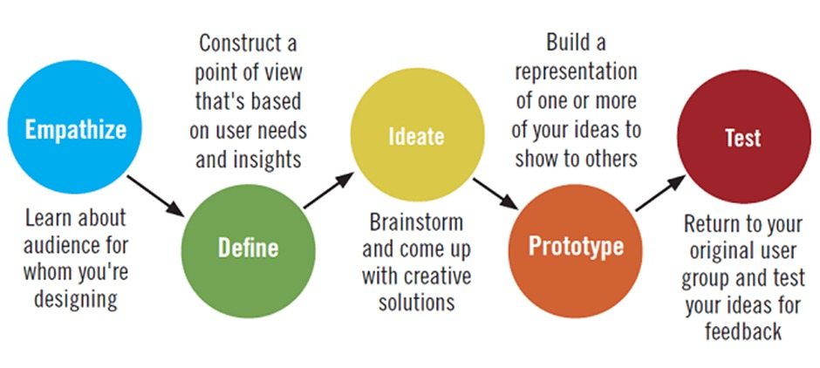

* The design process is iterative.
* It is driven and refined by user-centered evaluation.

Advantages :

* It improves and creates solutions which are easier for human to use/understand.
* It helps in overcoming poor design products.

Disadvantages :

* The complexity is present when developing the software
* It usually takes more time.

Example :

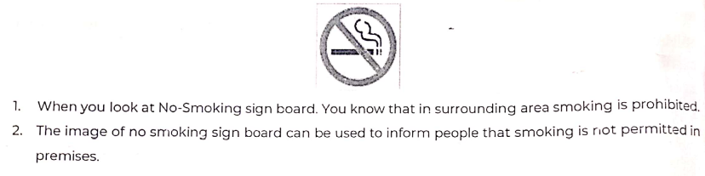

***Software Evolution Process :***

The process of developing a software product using software engineering principles and methods is called as Software Evolution. It is referred to as the process of developing, maintaining and updating software for various reasons.

CIRSS

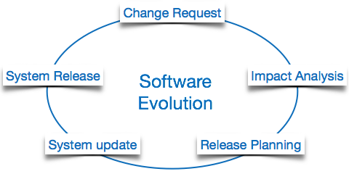

Evolution starts from the requirement gathering process. After which developers create a prototype of the intended software and show it to the users to get their feedback at the early stage of software product development.

The users suggest changes, on which several consecutive updates and maintenance keep on changing too. This process changes to the original software, till the desired software is accomplished.

Even after the user has desired software in hand, the advancing technology and the changing requirements force the software product to change accordingly. Re-creating software from scratch and to go one-on-one with requirement is not feasible. The only feasible and economical solution is to update the existing software so that it matches the latest requirements.

Software Evolution Process Laws :

*According to Lehman's laws of software evolution, on the one side, the size and the complexity of a software system will continually increase in its life time; on the other side, the quality of a software system will decrease unless it is rigorously maintained and adapted.*

1. S-type (Static-type)

- It works strictly according to the defined specifications and solutions.

- The solution and the method that needs to be used to develop the application are both understood before coding.

- It is least subjected to changes hence this is the simplest of all.

- For example, calculator program for mathematical computation.

2. P-type (Practical-type)

- It is one where specification exists, but it is high-level and not fully detailed. So the developer needs to put effort in figuring out concrete solution.

- The specifications are described but the solution is not instant.

- For example. Gaming software.

3. E-type (embedded-type)

- The software has specifications and requirements but it changes constantly with respect to the changes in the real-world environment.

- The software will be developed but if the market has new technology which needs to be adapted to then the software will need to be upgraded by making new changes accordingly.

- It is the best amongst all the three type, because change is constant.

- For example : Online Trading Software which needs to be updated when changes occur in law rules, taxes, etc.

Advantages :

* One benefit of having a better software evolutionary models is that the user can check the software progress and depending on their needs the new requirements can also be added to the developing system in hand.
* It supports changing environment.
* Risk Analysis is better

Disadvantages :

* Management complexity is more.
* It is not suitable for smaller projects.
* It can be sometimes costly to use.

***Gestalt’s Principles :***

* It is a German word for “Shape” or “Figure”
* It is also know as the Law of Simplicity
* Gestalt theorists followed the basic principles that the “whole is greater than the sum of its parts”
* It is a psychology term which means “unified whole”
* In the simplest terms, gestalt theory is based on the idea that the human brain will attempt to simplify and organize complex images or designs that consist of many elements, by subconsciously arranging the parts into an organized system that creates a whole, rather than just a series of disparate elements.
* Our brains are built to see structure and patterns in order for us to better understand the environment that we’re living in.
* There are six individual principles commonly associated with gestalt theory:

*similarity, continuation, closure, proximity, figure/ground, and symmetry & order (also called prägnanz). There are also some additional, newer principles sometimes associated with gestalt, such as common fate.*

SCC-PFS-C

* Similarity

Similar elements are visually grouped together. It can be grouped by color, shape or size. In the example below, the unity occurs because the triangular shapes at the bottom of the eagle symbol look similar to the shapes that form the sunburst. Similarity can also be used to tie together elements from screen which are not close to each other in a design.



* Continuation

The law of continuity tells us that the human eye will follow the smoothest path when viewing lines, regardless of how the lines were actually drawn. In the following example the eye wants to follow the straight line from the start to the end of the horizontal line or it prefers the curved line from the top to the bottom, even when the lines change colours midway. Since the eye naturally follows a line, placing items next to each other in a series fashion will naturally draw the attention of the user to the particular item.

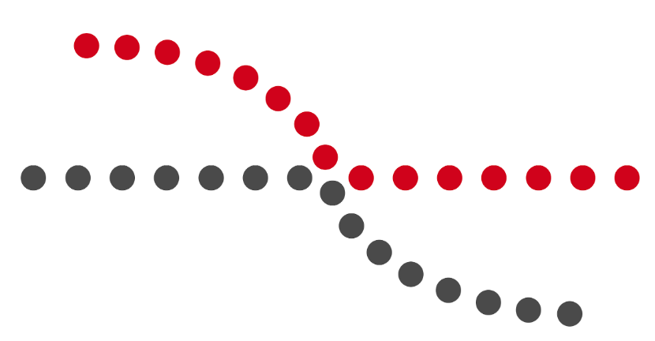

* Closure

The principle of closure tells us that when our eyes perceive a certain object which is half complete in nature, our minds will fill the half complete or negative space and see the picture as one unified object or a complete object. In the example below, the image of the panda is not complete but enough is present for the eye to complete or fill the “empty space”. When the perception completes a shape, closure occurs.



* Proximity

The law of proximity tells us that the components or objects in a design are perceived based on how close these objects are to each other. For example in the following example the first figure is perceived as a single group and in the second figure we perceive it as two different groups. This occurs because there is a distance between two groups which creates a difference between them.

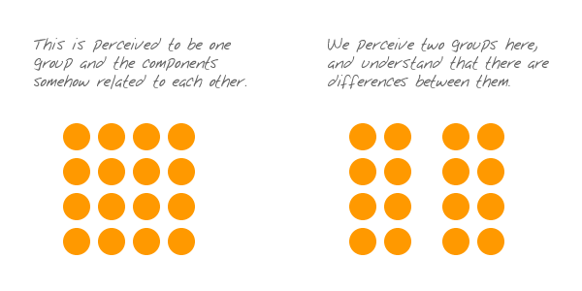

* Figure/Ground

This principle is similar to closure but it takes advantage of the negative space. Our brains will try to distinguish between a foreground image and a background image. Since both these parts of image has meaning behind it. The following diagram beautifully explains this feature where the two shapes of two person and a vase is shown. Another example is of the FedEx logo in which the space between ‘E’ and ‘x’ is shown as an arrow.

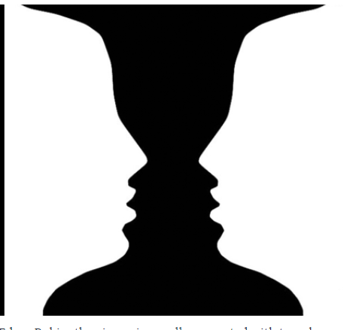

* Symmetry and Order

The objects which are balanced and symmetrical is perceived as complete or whole.

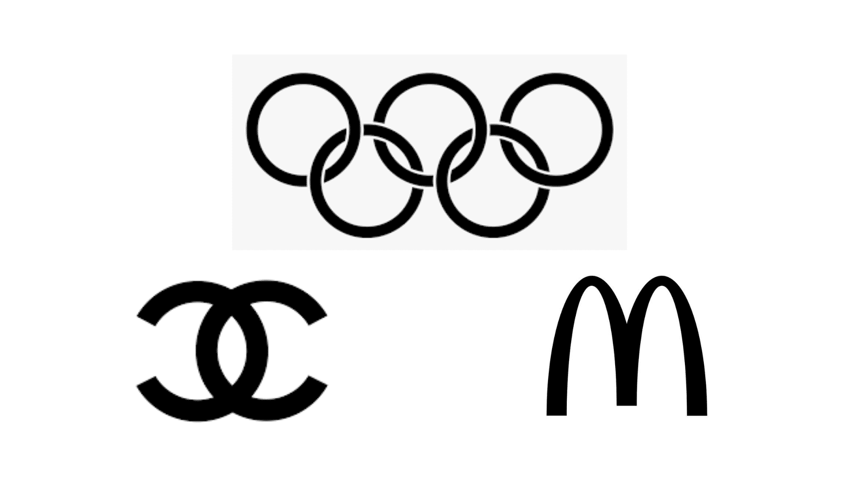

* Common Fate

This is new principle in Gestalt theory. It explains that people will group things together when they are pointing to or moving in the same direction. For example : flock of bird or school of fish. We can see that in these image, the picture consists of individual components but as they move as one or in one direction we perceive it as group or consider them as a single stimulus.



***Long Term Memory and Short Term Memory ? Issues related to LTM & STM ?***

Short Term Memory : It is also known as the active memory. It is the information; we are currently thinking or aware about. The information in short term memory will be kept for approximately 20-30s. For example, in order to understand this sentence, the beginning of the sentence needs to be held in mind while the rest is read, a task which is carried out by the short-term memory.

Issues : It requires concentrated effort on the part of the individual. If they become distracted due to some noise or distractions in the environment then the concentration can be broken and the content of short-term memory may be lost. For instance, if an individual is reading a book and has to go to open the door to get some delivery and then the individual gets a phone call, the individual will easily forget the information that he/she was trying to read or understand. For the information lost the individual might have to go back to the information he/she remembers.

Long Term Memory : It is intended for storing information for longer periods. Here information stored includes factual information, knowledge, experiences, behaviours and everything we ‘know’. Information received from short term memory is transferred to long term memory and encoded withing it, a process we call learning. However, there is also evidence that long term memory encodes information to some extent by sound. For example, when we cannot quite remember a word but it is “on tip of the tongue”, this is actually based on the sound of a word, not its meaning.

Issues : The issues in long term memory can vary from one individual to another depending on how good their health is. For example a person suffering from depression or diseases will have problems recalling memories.

Importance in Designing Interface :

* To design an interface in such a way that the sensory memory of the user should not be loaded with information and should be made easy to grasp or understand the design used by the user.
* The designers should strive to design the system for STM. The memory load is lighter and the interaction is faster and made error-free.
* For example, when the user has browsed through different websites on google, the idea of providing a difference in showing the websites that are visited and not visited by using two colours can be implemented. This helps the user in easily recognizing the websites that were earlier visited simply by looking at the change in colour which in turn means that the user does not need to remember the websites they visited hence decreasing the load from memory.
* According to Miller’s law, the designer should not load all the elements in one interface. It is better to break it down into steps or to follow a certain hierarchy which can help the individual understand rather than confusing them.

Module 02 : Understanding Goal Directed Design/ Design and Software Process

***What is persona ? Mention steps in designing persona.***

Personas are fictional characters, which we create based upon the our research to represent the different user types that might use a particular organizations services, product, site or brand in a similar way.

Creating personas helps in understanding the user’s needs, behaviours, experiences and goals. It also helps in recognizing the fact that different users will have different needs and expectations. It helps to identify with the user we are designing for. It is a human-centric design process.

Personas are consistently used in marketing and advertising because customers are at the core of these two industries. It helps them recognize their target group.

Personas are represented as individual people or group of users.

Steps in Constructing Persona :

IAR-G-CED

1. Identify user behavioural patterns : It is the first step in designing a persona. The behavioural patterns are recognized by collection information or data of the users.

2. Arrange Interview : Depending on the user, decision should be made on how many interviews will take place, how many survey responses are required to reach a certain conclusion.

3. Recognize user behavioural patterns : user behavioural patterns can be recognized by using :

- open-ended responses to questions

- utilize surveys

- virtual/in-person group discussions

- reverse Q&A sessions.

4. Generate various user characteristics and relevant goals : Note down characteristics, goals, pain points and other relevant information that would relate to the eventual product use. The goals will help in building the persona.

5. Check for completeness of goals : Timely schedule must be made to check the completeness of goals.

6. Explain all attributes and behaviour of user : Attributes such as name, purpose and objective is explained and behavioural aspects of the user is considered.

7. Design various personas : It is the last step. Based on all the information collected a persona of the user or a group of individuals is created. Personas include goals, challenge, role, etc.

***Qualitative and Quantitative Research. Techniques in Qualitative Research. Difference between two.***

Qualitative Research :

Qualitative Research is a type of research where the researcher simply observes the environment in which people or a particular individual works and how they perceive their environment. The researchers try to understand phenomena, experiences, perspectives, opinions and meaning. The deductions made from this research or the data is not numerical in nature. The data can be videos, interviews or experiences. Therefore, the gathered data is very natural and can be semi-structured or unstructured in format. The most popular techniques used include interviews, case studies, observations. Group discussions and questionnaires with open-ended questions. It is kind of an exploratory research.

Techniques :

1. Direct Observation

A researcher studies people as they go about their daily lives without interfering or participating. The research is often unknown to those under study. For example, a researcher may observe how strangers react to a street performance happening in a public space.

2. Open-Ended Surveys

Mostly surveys tend to be a quantitative approach but in cases like asking open-ended questions to the users it becomes qualitative. For example, a survey can be done to investigate not just which political candidates voters chose, but why they chose them, in their own words.

3. Focus Groups

A focus group usually consists of a researcher and a group of around 5-15 participants. The researcher asks questions to participants and learns about opinions on a particular topic. For example : A focus group of parents of pre-schoolers meets to discuss child care needs.

4. In-depth interviews

Researchers conduct interviews where in-depth questions are asked to a participant. The interview is in a one-on-one setting. Sometimes the researcher will have a list of predetermined questions that will help him/her guide the interview process but also allow the natural rhythm or flow of the interview based on how the participant responds to their question.

5. Oral History

An oral history is an interview between the narrator and the interviewee. The discussion is about the narrators history and their experiences on a particular topic. The interviewee notes down and keeps records of the events occurred but doesn’t make a conclusive statement out of it, since the experiences of the narrator are subjective in nature.

6. Participant Observation

This method is similar to direct observation but here the researcher gets involved with the participants to not only observe but also to gain first-hand experience of the event occurring.

7. Ethnographic Observation

It is the most intensive and in-depth observation carried out by the researcher. It originated in anthropology, where the researcher spent time and even lived with them for a period of months or years. The researcher understands the community in every aspect after the research is completed.

8. Content Analysis

This method is common among sociologists. The researcher analyses social life by looking at certain words from different data sources like films, videos, art, music, images, text and other cultural product and media. The researcher recognises how words are used in a context and draw inferences about the underlying culture in which they are used. Example: Watching various television series from different eras to determine how minorities are depicted.

Quantitative Research :

Quantitative Research is a type of research where the analyses of the data is done from various numerical or statistical data. The source of data is from the internet and is called as “dataset”. The data is structured unlike qualitative which is unstructured. The data is understood by looking at the patterns that occur, predictions are made for possible outcomes and relationships between different variables are checked for to understand how every other variable is correlating to each other. The results of this data is displayed in a visualization format usually a graph, charts, plots etc and presented to the wider population for understanding. It makes conclusion from the given data.

The most popular techniques include :

Surveys : paper, kiosk, mobile, questionnaires.

Correlation, regression analysis method, Polls, experiments, interviews, observation, etc.

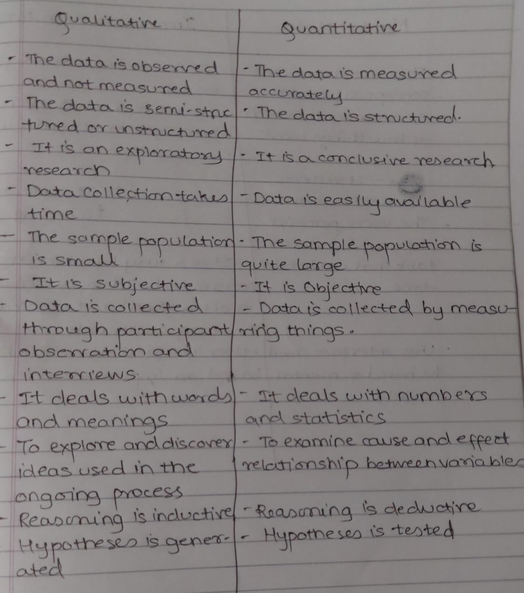

***Mental Model***

A mental model is an explanation of a person’s thought process about how something works in the real world. It is an abstract representation of the world view. It maybe or may not be true. It is representation of the surrounding world, the relationships between its various parts and a person’s intuitive perception about their own acts and their consequences. The model is less complex than the real world.

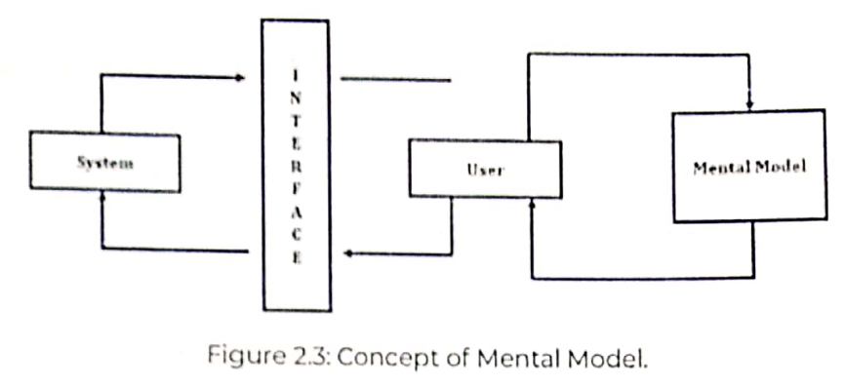

Drawbacks :

* Since the mental model is influenced by a person’s own judgment about their surroundings, it will include biases that might block the real world view.
* If the same old mental model is used to view the world, the user might see a traditionally distorted worldview.

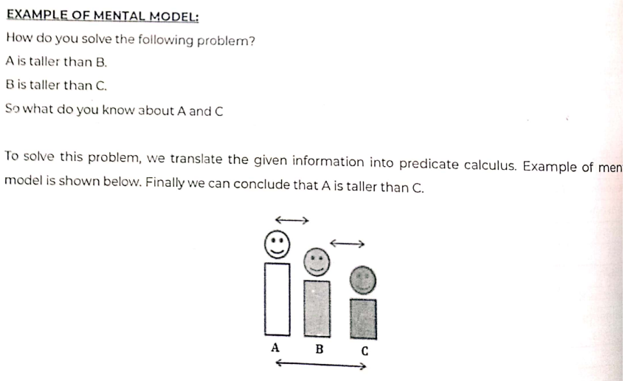

***State various interview technics***

The following are the three formats of interviews: structures, semi-structured, unstructured.

1. Structured Interviews

- It is also known as standardized interview.

- It is a quantitative research method

- The researcher conducts an interview with an individual in one-on-one setting and interrogates from a predetermined list of questions.

- It is a more straightforward question-to-answer like session.

2. Unstructured Interviews

- It is also known as non-directive interview.

- It is a quantitative research method.

- In this interview, the questions are not pre-arranged.

- The interview process happens in an informal manner.

3. Semi-Structured Interviews

- It includes both features of a structured and unstructured interviews.

- It is a quantitative research method.

- The interviewer prepares a set of questions to ask but not necessarily will follow the formal manner.

- It is a very free way of interviewing where the questions asked are open-ended questions and the interview is more like a discussion process rather than a meeting.

**Goal Directed Design Process**

* It is a user-centric based process
* It was developed by Alan Cooper
* It is a research-based software-design method for anticipating how people will respond to a new or modified product or system.

The design process is broken down into six step that comprise interactive research and user behavior analysis.

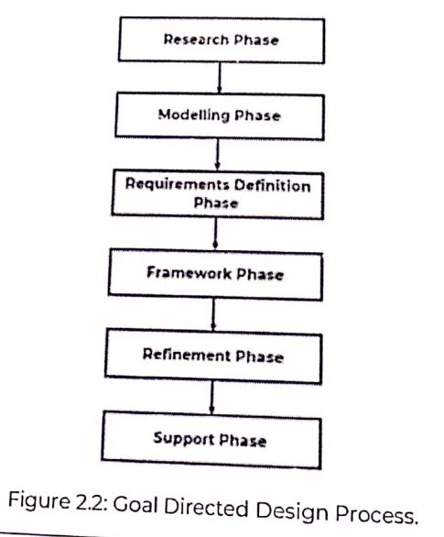

RM-RF-RS

1. Research : The aim is to collect maximum amount of relevant data of the users. It is done by doing ethnographic analysis, surveys and user observation. The result of this step should be an analyzable pattern of user behaviour.

2. Modelling : This phase combines all the data collected and creates a persona of the user which includes information of their behaviours, characteristics etc. This phase helps in understanding the user in detail.

3. Requirement Definition : It is the most important phase is goal directed design. It is used for requirement collection. It is used to provide connectivity between the user, models and product framework.

4. Framework : It is used to provide actual product design and framework for the system behavior. It demonstrates the overall design structure and a solid idea for the interface.

5. Refinement : The aim of this phase is to create a mature and detailed design documentation.

6. Development Support : Since technology is changing and dynamic in nature. It is important to keep the design in line with the latest working technology and to maintain the central idea of the design intact.

***Logo Design***

* A logo is a symbol that consists of images or texts which represent the identity of a company or a brand.
* A good logo contains what the brand values and works for.
* Logo design is all about creating a perfect visual brand mark for a company.

Types of Logo Design :

1. Iconic/Symbolic : It is a type of non-typographic logo which consists of visual elements or simple images that resemble what the brand wants to portray. Example :



2. Logotype/Wordmark : It is a type of typographic logo which contains letters that usually represents the name of the brand or the company.

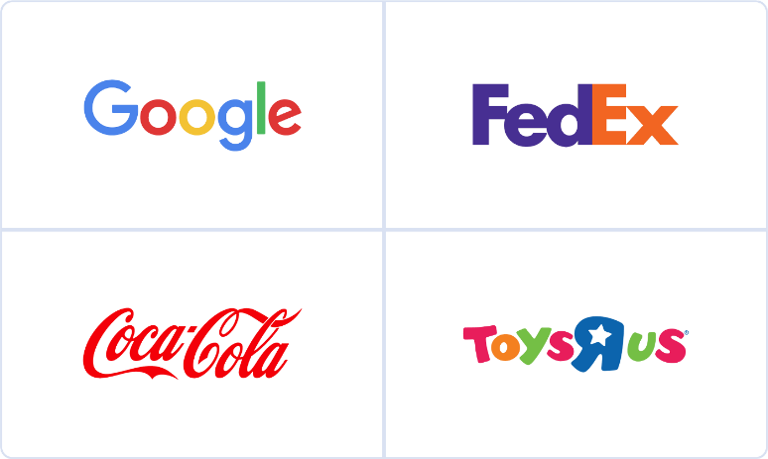

3. Combination Mark : It is type of logo which consists of both images and letters to represent the brand.



Pros :

* A logo which uses colors and is minimal visually makes the logo grab attention easily and is memorable.
* A good logo can make a first strong impression.

Cons :

* A logo which has too much of information in it can make a bad logo.
* Using font type and colors that don’t identify with the brand work will create a poor logo

***Designs for accommodating users OR What are three categories of the users? How they can be provided with facilities to ensure feasibility in operation?***

* The main goal of the designer is to first identify if the type of user using the system is an expert of a beginner.
* Since the users using the system are people from varying backgrounds and experiences it can usually be divided into three following categories :

1. Beginners

2. Intermediators

3. Experts

1. Beginners : Every user is a beginner when they start to use the system in the early stage of their life. The beginner requires a lot of help from system to navigate and use the system. The main focus area of beginning users is on : *Menus and Messages*

Questions from beginning user :

* Which program should I use?
* From where should I start?
* How do I move to next program?
* Am I doing things right?

2. Intermediators : This level consists of maximum of users using the system. The knowledge these users have allows them to easily use the system with less doubts regrading how the system works.

Questions from Intermediator user :

* I know it exists … but where?
* I’ve done this earlier but the elements are new, how do I follow from here?

3. Experts : The number of experts using the system is quite small compared to other two type of users. The experts have knowledge that brings no doubt and can without any questions can also use the system. Questions arises when the expert wants to get involved with the system. They always look for customization or automation in the system. The company ask advice to experts for any improvements to the system. When experts find that a certain program is not working for example command prompt, they are knowledgeable enough to start using Windows Powershell.

Questions :

* Can I personalize this feature from the system?

***What is design and explain interaction design process***

Design is defined as achieving goals with constraints and encompasses work tasks data design, architectural design, interface design and component-level design and create a design model or specification.

Interaction Design Process :

The interaction design process is what designers use to create solutions centered on users needs, aims and behavior when interacting with products.

The following figure shows the simplified view of the four main phases and an iteration loop, focused on the design interaction.

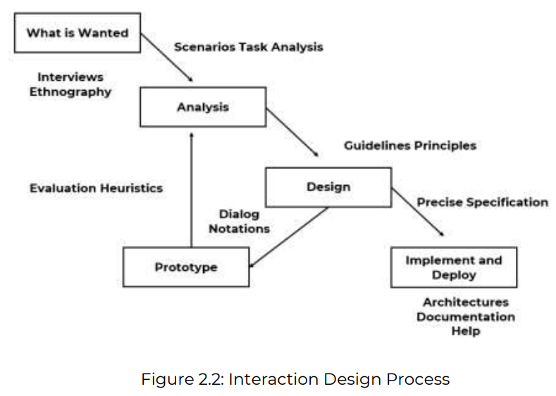

Steps :

1. Requirements (What is wanted) :

- It simply means gathering requirements regarding what the user needs/ wants. The information can be collected by interviewing people, observing people and examining existing solutions.

2. Analysis

- To sort and order the previous findings to get key points that make sense. This can be a narrative story of how a system work and breaking down the users steps in using the system into sub-steps.

3. Design

- To design a system based on principles of designs and develop a solution based on the best available techniques.

4. Iterating and Prototyping

- The design created may or may not be up to mark considering all the scenarios that we still aren’t aware of. Handing the prototype of the system to users and getting feedback from them or experts can help make necessary changes and create a system that works in most of the cases.

5. Implementation and Deployment

- Finally when the design is completed and necessary changes made the design is finally ready to be deployed in the real world for everyone to use. This can involve creating software, writing documentation of the system for the users to understand.

***Eight Golden Rules of Interface Design***

When developing system the most important is how well the systems interface is designed. A good interface can help and make access to elements in website easier to user but a bad design can irritate the users when using the system. Therefore, following a principle that can help achieve consistency and easy of use is very important.

Ben Shneiderman’s “Eight Golden Rules of Interface Design” is a guide to a good interface design.

SEO-DOPSR

Strive for

1. Strive for Consistency

Whether it is the layout, the size of the button, the color code, menu hierarchy or the tone used when writing the page, it is important to be consistent throughout the site. This consistency will allow you to develop your identity and not lose users as they navigate your site.

2. Enable frequent users to use shortcuts

Allow your users to access all parts of the website with a minimum of clicks. To do this, you not only need to establish a good hierarchy in the menu, but also make things clear. For example, Windows and Mac provide copy and paste to help complete the task more fast and efficiently.

3. Offer Informative Feedback

When the user is using the website it is a good practice to display the feedback after every action done by user. This helps the user to recognise which process has completed or is working. For example when using Google Drive, when we drag a new file from our desktop to drive it displays a window which shows progress of the file transfer to drive. This helps the user in recognizing how much time it takes which lets the user to continue his/her work. A bad example is when error is caused and the system shows error-code in the message and not a human-readable text.

4. Design Dialog to Yield Closure

When a user makes a list of actions together, based on the cause of the action, one should provide informative feedback that can bring relief to the user after completing a group of actions or task. For example when the user fills details of their information for placing an order, a “Thank you, you order has been placed” feedback can be shown to yield closure.

5. Offer Simple Error Handling

Users tend to make mistakes and error are inevitable. One should design a system that can handle the error by correcting it or guiding the user by providing solutions to the error. For example, when a particular user puts their login information on a website and the password is wrong. “Sorry, the password was incorrect” message should be shown.

6. Permit Easy Reversal of Actions

When user by mistakenly deletes a file an option to Undo the action should be provided. This helps in bringing relief to the user knowing that the errors can be reversed. As Shneiderman states in his book : “This feature relieves anxiety, since the user knows that errors can be undone; it thus encourages exploration of unfamiliar options”

7. Support Internal Locus of Control

One should give more control to the user when using the system, as it allows the user to use the system in freedom and perform actions and choose options based on their own will. By doing this we create a system that makes the user feel that they are in more control to the system. For example, the bell icon on YouTube channel. By turning on or off button on the bell, the user can choose whether he/she wants to get notifications of that particular channel. Hence, giving more control to the user in seeing the content they wish on their system.

8. Reduce Short Term Memory Load

The human limitation when processing information through a short-term memory requires that the system should not overload the user with a lot of information. By doing this we lose users attention as the user can’t focus on everything at once. By creating a minimalist design and menus that are easy to use we create a design that the user can smoothly navigate.

***Universal Design Principles***

* It is the design and composition of an environment so that it can be accessed, understood and used to the greatest extent possible by all people regardless of their age, size, ability or disability.
* An environment needs to be designed in such a way that any type of person that wishes to use it should be able to use it easily.
* When it is accessible to people of all types, everyone benefits from it.

The following are the 7 Principles of Universal Design which were developed in 1997

1. Equitable Use :

The design is useful and marketable to people with diverse abilities

* Provide the same means of use for all users : identical and equivalent
* Avoid segregating or stigmatizing any users
* Safety should be available to all users
* Make design appealing to all users

Example : A desk surface may be raised or lowered to accommodate users of varying height or an individual who uses a wheelchair.

2. Flexibility in Use

The design accommodates a wide range of individual preferences and abilities

* Provide choice in methods of use
* Accommodate left or right side access and use
* Provide adaptability to the user’s pace

3. Simple and Intuitive to Use

Use of the design is easy to understand, regardless of the user’s experience, knowledge, language skills or current concentration level.

* Eliminate unnecessary complexity
* Be consistent with users expectation and intuition

4. Perceptible Information

The design communicated necessary information effectively to the user, regardless of ambient conditions or user’s sensory abilities

* Use different different modes such as pictorial, verbal, tactile for presentation of information
* Provide compatibility with variety of techniques or devices used by people with sensory limitations.

5. Tolerance for Error

The design minimizes hazards and the adverse consequences of accidental or unintended actions.

* Provide warnings of hazards and errors
* Arrange elements to minimize hazards and errors

6. Low Physical Effort

The design can be used efficiently and comfortable and with a minimum of fatigue or stress.

* Allow user to maintain a neutral body position
* Minimize repetitive actions
* Minimize sustained physical effort

7. Size and Space for Approach and Use

Appropriate size and space is provided for the user to reach and use the system regardless of user’s body size, posture or mobility.

* Accommodate variations in hand and grip size
* Make reach to all components comfortable for any seated or standing user.

Examples : Curb Cuts, Sloped Entrances, Automatic Doors

Usability Design Principle

Module 03 : GUI (Graphical User Interface)

***What is Direct and Indirect Manipulation?***

Direct Manipulation :

It is an interaction style in which users act on displayed objects of interest using physical, incremental, reversible actions whose effects are immediately visible on the screen.

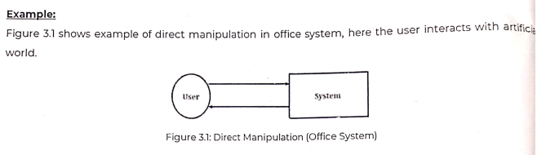

Characteristics :

1. Continuous representation of the object of interest : When users use a particular program they can see the visual representations of the objects that they can interact with. As soon as they perform an action, they can see its effect on the state of the system. For example when moving a file from one folder to another the user can see the file and once the user drops the file the image of that file disappears basically informing the user that the drag-and-drop method or the file was moved successfully. Hence it creates a satisfaction in the user.

2. Physical Actions instead of complex syntax : The user can easily move the files by clicks, button presses, menu selections and touch gestures. In the move-file example, drag-and-drop has a direct analog in the real world, so this implementation is easily learned and remembered. In contrast, when it comes to command-line-interfaces the user needs to recall the name of not only the commands but also the filenames for a successful operation to happen. Thus, command-line interfaces are based on recall instead of recognition.

3. Continuous feedback and reversible, incremental actions : Because of the visibility of the system state the user can see what object is moving to which file very easily, since the feedback of that moving file is visually seen. Therefore even when error happens the actions to remove the error can also be easily done. Therefore the actions are reversible in nature. In contrast, with command-line-interfaces when the user types a file name, the system might automatically assume a file name not required. When the user checks if the file was successfully moved, without being aware that the system assumed the name wrong, can take a lot of time just in looking for the error.

4. Fast and Rapid Process : Since the user can visually see things happening this becomes the major advantage. The user can speed up the process by knowing when to and the feedback is very fast and therefore anytime taken can be completed in a very short period. They do not need to learn anything new like command-line-interfaces where it works on recall.

Adv :

* Easy to learn
* Permit error avoidance

Disadv

* It is difficult to code
* It requires graphic displays and pointing devices

Indirect Manipulation :

It substitutes words and text, such as pull-down or pop-up menus, for symbols and substitutes typing for pointing.

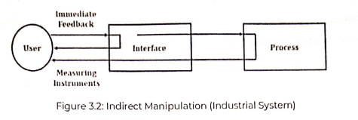

* The operations maybe difficult to conceptualize
* The graphics capability maybe limited
* The amount of space available for placing manipulation controls maybe limited
* It maybe difficult for people to learn and remember all necessary actions

Adv :

* Easy to code and implement
* It does not require pointing devices

Disadv

* Greater design complexity
* Inconsistencies in technique

***List General Principles of User Interface Design give example Or Factors of User Interface Design and provide innovative web application.***

* User Interface Design is also known as User Interface Engineering
* It is the design of user interfaces for machines and software, such as computers, home appliances, mobile devices, and other electronic devices
* It basically focuses on maximizing usability and the user experience
* The goal of user interface design is to make the user’s interaction as simple and efficient as possible

A3C4 – CDEF2IQ – OP2MPR2 – S2T2V

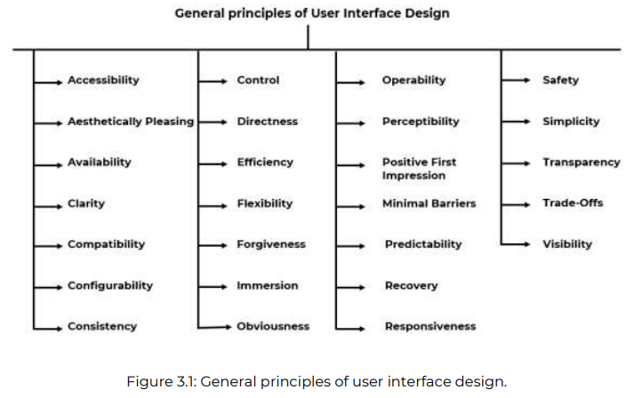

1. Clarity

- It is the most important element of user interface design

- It means the information content is conveyed accurately

- Clarity must be reflected in the concepts, languages and vision including :

a. Visual Elements

b. Functions

c. Metaphors

- Example : Tooltip is used to explain the functionality of buttons

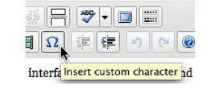

2. Consistency

- It means the design and behavior across every part of the system should be similar

- A system should look, act and operate the same throughout

- Similar components should

a. Have a similar look

b. Have similar uses

c. Operate Similarly

- Consistency enables users to develop usage patterns

Example : The Microsoft Office user interface is consistent for all applications such as Word, Excel, PowerPoint, etc.

3. Responsiveness

- It means that the interface is able to respond to every user action

- The response received is fast

- Another aspect of responsiveness is feedback, it is important to inform user if their actions are happening in right manner.

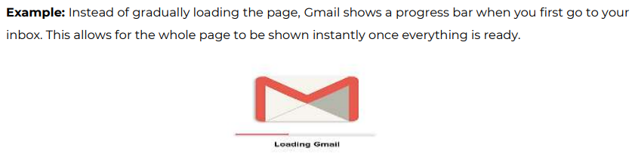

4. Efficiency

- It means achieving maximum productivity with minimum effort.

- A good UI should allow the user to perform functions faster and with less effort.

- Efficiency minimize eye and hand movements and other control actions.

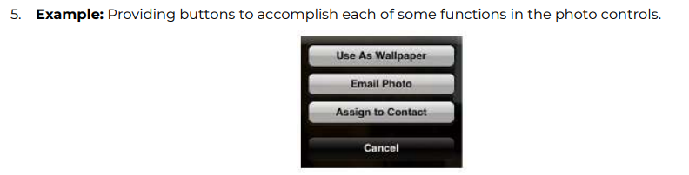

5. Forgiveness

- The users are bound to make mistakes when interacting with the interface

- It is important to guide the user by correcting the error or displaying options that can help user in taking steps to resolve the error

- Human errors are inevitable and must be tolerated and forgiven

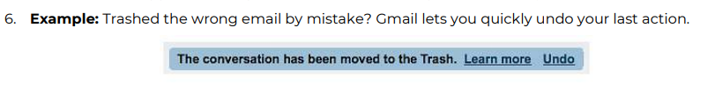

6. Attractive

- A good user interface is visually appealing in look.

- The user should feel good when using the interface by using different colors font etc.

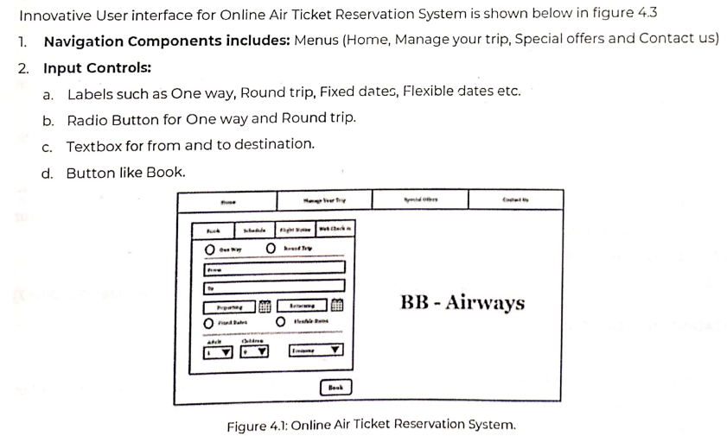

***What are the adv and disadv of Digital/Graphical Systems***

Graphical System allows user to interact with electronic devices through graphical icons and visual indicators.

Advantages :

1. Symbols recognition is faster than text : Symbols are faster to recognize than words because words take time to read and recognize. Graphical Attributed of icons such as shape and color allows the user to quickly group them into a certain category

2. Faster Learning : Research has shown that pictorial representation increases learning speed and symbols can be learned fast. Using symbols one can easily identify with the object.

3. More attractive : Using icons or images creates a very visually appealing interface for the user to use. Examples : Games like temple run

4. Easier Remembering : Because of the simplicity of the icons on interfaces it is easy to remember what each icons context is.

5. Fewer Errors : There are less errors because the system is very simple in design and even when error happens from user, the reversibility of actions is possible.

6. Less Anxiety concerning use : New users that haven’t used the system before are not anxious to use the system because of its minimal design.

7. May consume less space : icons take less space compared to words

8. Low typing requirement : Pointing and selection controls such as mouse and trackball eliminate the need for typing skills.

9. Increased feeling of control : The user initiates the actions and feels more in control. This increases the confidence of the user.

10. Smooth transition from command language system : Moving from command language system has been found easy.

Disadvantages :

1. Greater Design Complexity : To design a unique icon which represents a brand or an item is complex. The designer has to spend time in creating an icon which is not same from the available icons due to legal issues.

2. Learning still necessary : There are icons that are not clear right when the user looks at it. For example when installing a new application the icon might not give away the meaning example icon of Google Chrome. Learning needs to happen to understand the icons use.

3. Inconsistency in technique and terminology : Inconsistency occurs because of copyright and legal implication. It affects the graphical system.

4. Hardware Limitations : Good design requires hardware of high functionality and power. Using an old hardware the user is only open to the old versions of graphical icons which are not even used.

**GUI Vs Web Page.**

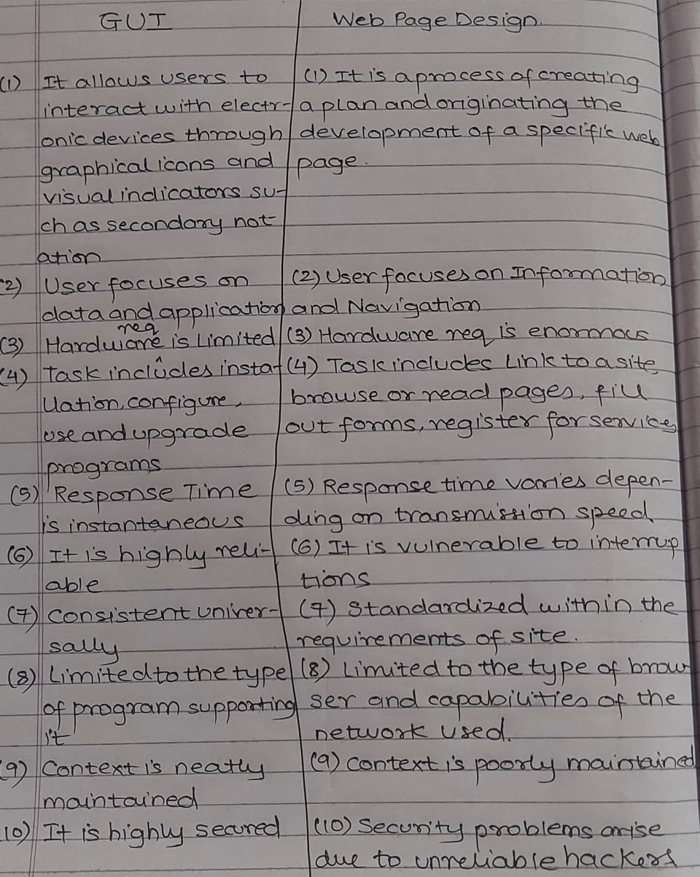

Module 04 : Screen Designing

What is statistical graphics explain types

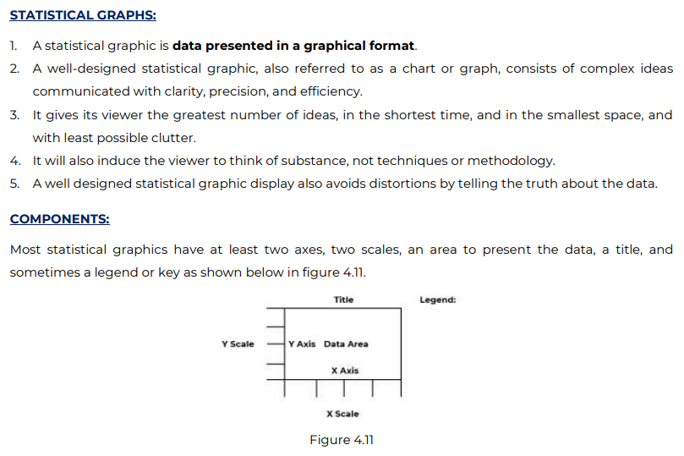

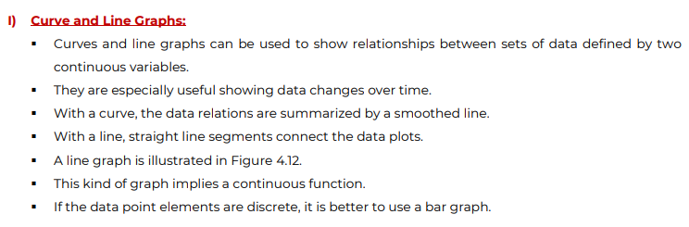

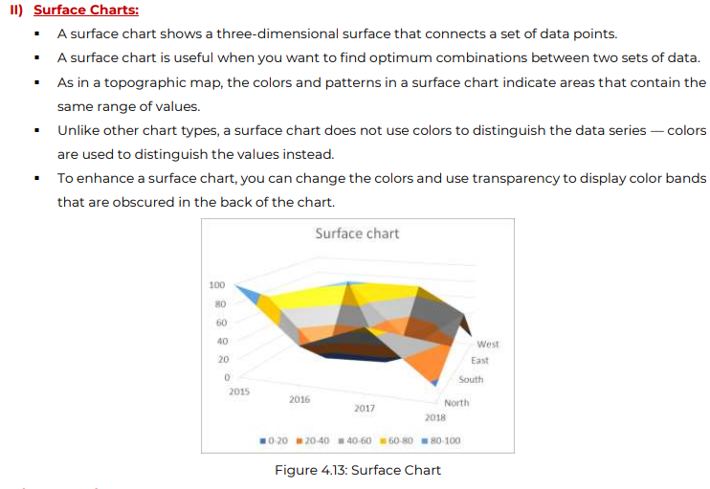

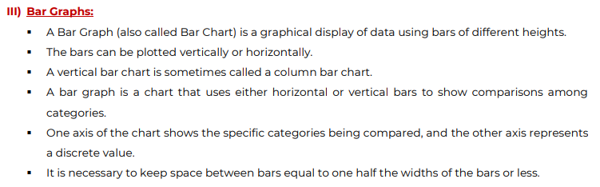

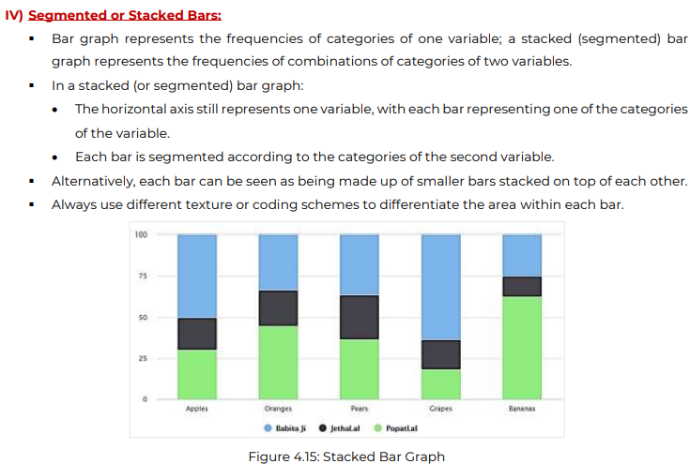

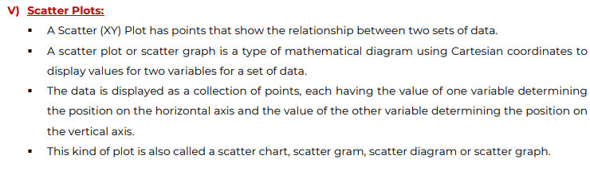

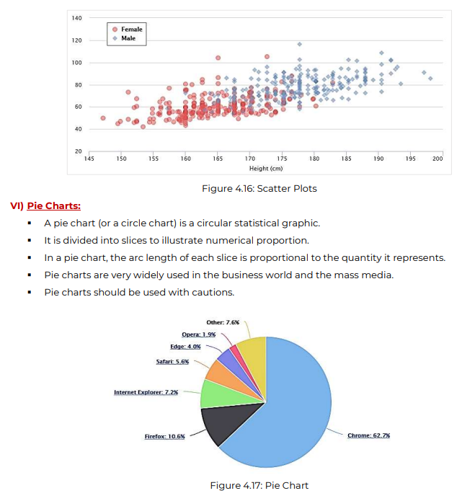

Explain techniques of organizing screen elements, ordering of screen data and content

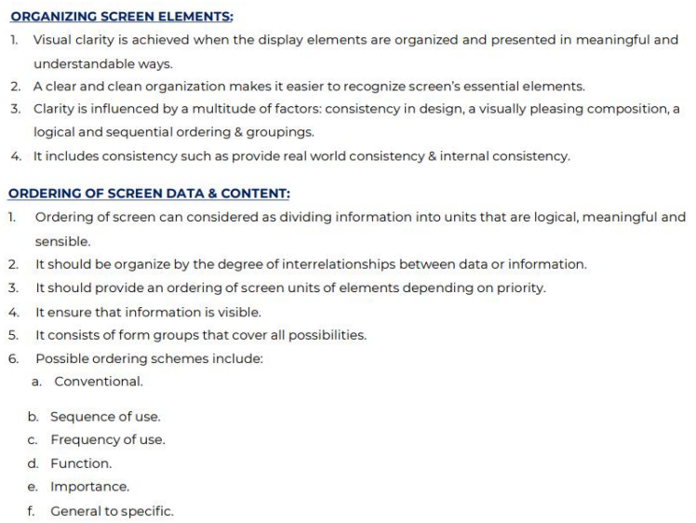

How reading is imp in UI design? Write your comments related to the quote “Poor design may affect reading”

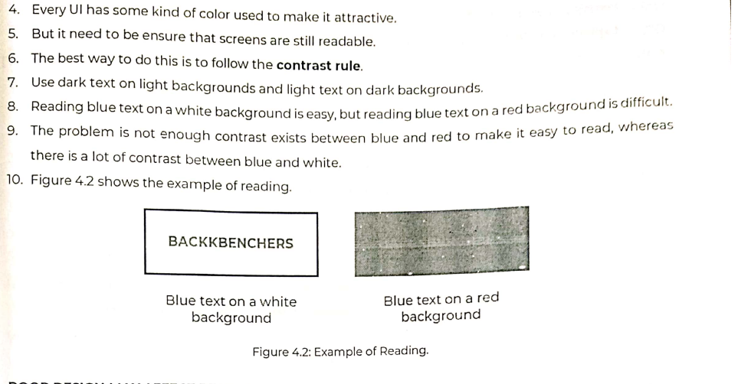

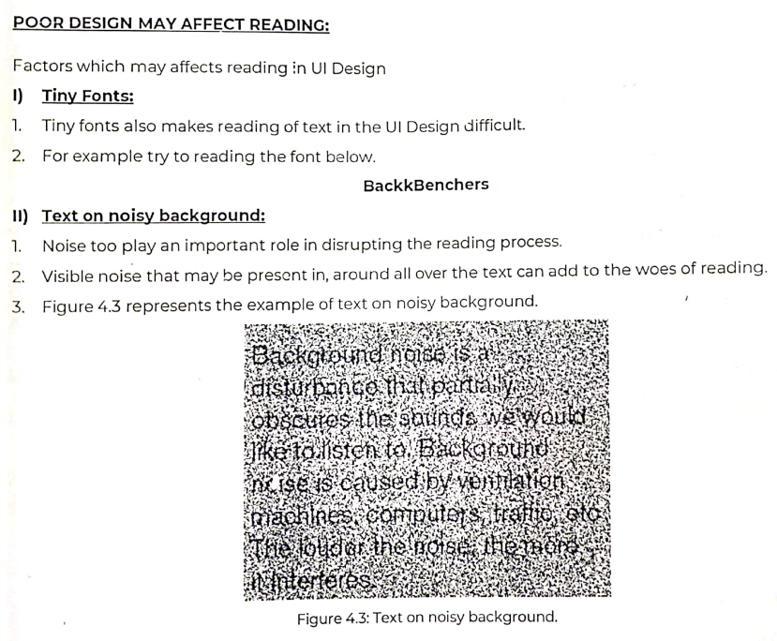

Module 05 : Interface Design for Mobile Devices

**What is Mobile 2.0? Principles of Mobile 2.0**

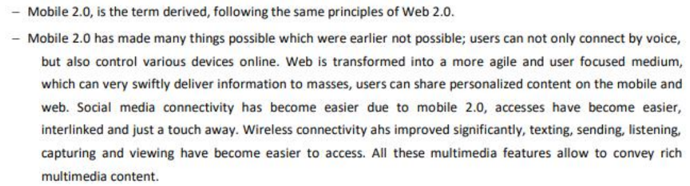

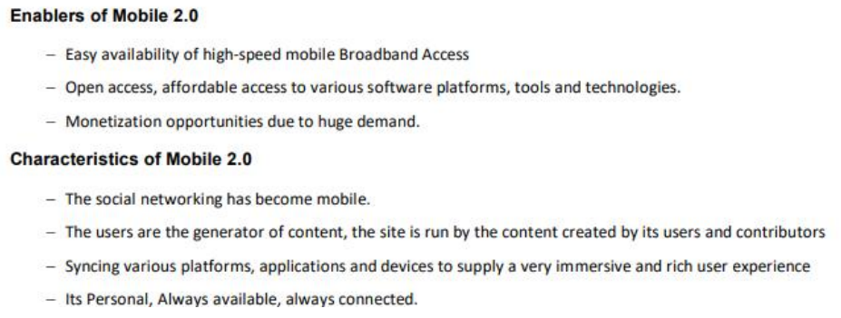

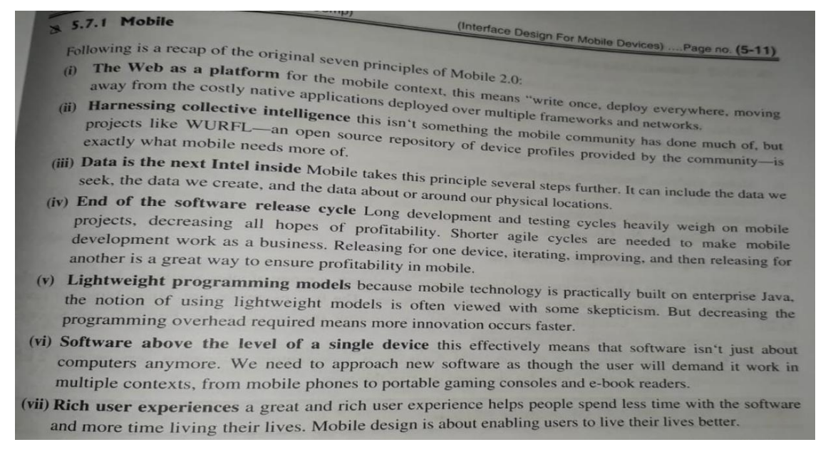

**Mobile Ecosystem and its Layers**

Internet is built by many components that aim to work together to provide user information and various facilities. Similarly Mobile device has many layers to it that works together to give different kinds of services to the end users. Mobile is an entirely unique ecosystem that consists of various components.

The following diagram shows the components of Mobile Ecosystem

SAAOP-DANO

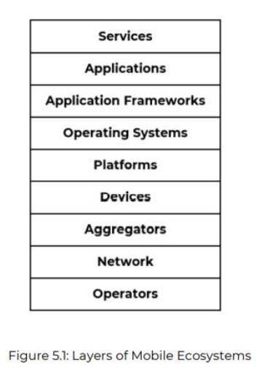

1. Operators

- It is the base layer in the mobile ecosystem.

- It can be referred to as Mobile Network Operators (MNOs)

- Operators are what essentially make the entire operating ecosystem work

- The role of the operator in ecosystem is to create and maintain a specific set of wireless services over a reliable cellular network.

2. Network

- Network is a pipeline to deliver data.

- Network means the transfer of data and the network technology includes how speed the data is transferred.

- Technologies include GSM, CDMA, GPRS, UMTS, LTE

GSM/CDMA -Slow

GPRS – Faster

UMTS (3G) – Fastest (currently)

LTE (4G)

3. Aggregators

Aggregators, or mobile enablers, are third-party companies (technology and otherwise) that bridge the gap between content owners (brands and publishers), carriers/operators, and consumers. They are a necessary middleman with untapped experience and knowledge that can’t be overlooked or undervalued. However, it’s important to partner with an aggregator or enabler that fits the communication goals of the specific mobile campaign at hand. Not everyone can be a jack-of-all-trades, and that’s not a bad thing when planning programs that reach consumers in one of the most personally relevant media platforms today.

4. Devices

The devices include phones, ipad, tablets, phablets on which the services are provided so the user can use these facilities as per their needs. The devices is where all the components are communicating to.

5. Platforms

- Its primary duty is to provide access to the devices. To run software and other services, we need a platform or a core programming language in which all of the software is written. Like all software programs, these are split into three categories : licensed, proprietary and open source.

Licensed :

* It is sold to device makers for non-exclusive distribution on devices. The goal is to create a common platform of development Application Programming Interfaces (APIs) that work similarly across multiple devices with the least possible effort required to adapt for device differences. Example : Java Micro Edition (Java ME), Binary Runtime Environment for Wireless (BREW), Windows Mobile, LiMO

Proprietary :

* It is designed and developed by the device makers for use on their devices. It is not available for use by competing device makers. Example : Palm. A Palm Pilot is a PDA or Personal Digital Assistant that can exchange information with a computer. In its simplest form, it is used as an organizer and scheduler and keeps track of contact information. Other examples is Blackberry and iPhone.

Open Source :

* Open Source platforms are freely available for users to download, alter and edit. It is a new platform version. It is gaining attention among various device makers. Android is one of these platforms. It was developed by Open Handset Alliance which is now spearheaded by Google.

6. Operating System

- OS is a software that bridges the gap between hardware and software applications. It gives access to resources from hardware to the applications that require it. It also provides various services and manages files as well as I/O system. Example : Windows, Linux, Android.

7. Application Frameworks

- Application Framework is a layer that sits right above the OS.

- It shares core services such as communications ,messaging, graphics, location, security, authentication, and many others.

- It allows to create applications such as game, web browser or media player etc.

- Example : Java, S60, FlashLite

8. Application

- Applications are the software’s that are installed by the users as per their choice.

- It includes different kind of application for different services.

- Example : Whatsapp for messaging, Facebook for Socializing etc.

9. Services

- Services are facilities provided by the application.

- For example Whatsapp provides user with services like texting, calling, video calling, sending stickers and photos etc.

***Keyboard Accelerators***

* Keyboard Accelerators are also called Hot Keys
* It includes a combination of two keys to use to speed up a certain task or activity.
* One of the keys is always CTRL key and the second key depends on the task at hand.
* It works even when the mouse cursor is moving.
* It is used to improve productivity.
* In most of the applications like Microsoft Word or Excel, it offers Keyboard Accelerators in their Menu options which can be listed into a pull-down menu.
* Though most commonly users prefer using the keyboard method instead of selecting it through a menu.
* An example of this is, If a certain paragraph from a web browser needs to be transferred to a Word Document, the user needs to use the keyboard accelerators twice. One is CTRL + C to copy the text from the browser and CTRL + V to paste the text into the Word Document.

The following table shows keyboard accelerators and their actions

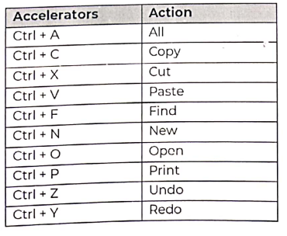

***Windows***

* A window is an area in screen, rectangular in shape, which is defined by a border that contains a particular information of a certain application or its properties.
* It can be moved from one part of the screen to another.
* One type of windows can overlap other type of windows but its not always this case.
* A windows may be small or large, sometimes the size is variable or is fixed depending on the type of situation in hand.

Characteristics :

* A windows header has a title which describes which application it belongs to.
* The size in height and width can vary.
* It usually includes a title bar. It also includes menu bar but not always.
* On the title bar it includes an option to minimize or maximize the window screen or exit or remove the windows from the screen.
* 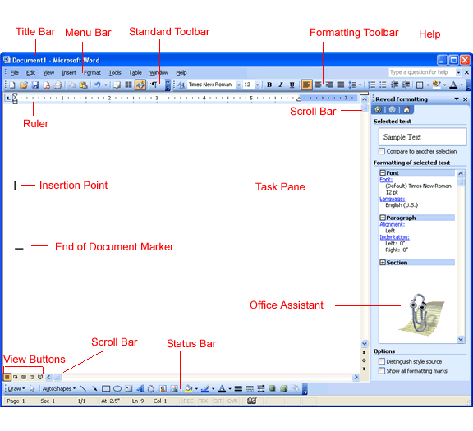

Types of Windows :

1. Primary Windows : It is the first window which appear when an application is opened. It is required for every application consisting of menu bars, scroll bars, title bar. It is also referred to as application window or main window.

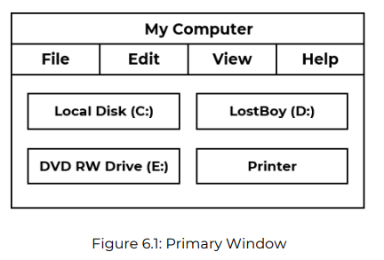

2. Secondary Windows : A secondary window is a supportive window that is dependent on a primary window (or another secondary window). In the secondary window, users can view and provide additional information about actions or objects in a primary window. A utility window is a window whose contents affect an active primary window.

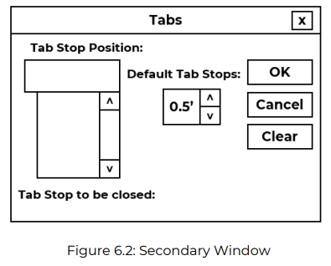

3. Dialog Boxes : A dialog box is a temporary window an application creates to retrieve input from user. An application will prompt a dialog box to the user based on the action the user has performed. For example to save a document, a dialog box will appear for the user to name the file to be saved which is the input and save the file.

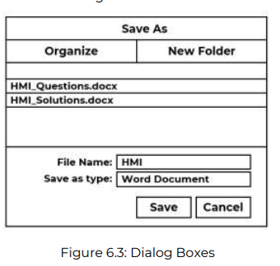

4. Property Sheets and Property Inspectors :

Property sheets is a type of window which displays complete information about a particular application and contains various tabs or pages that display it.

Property Inspectors is used to view and change properties of an object in a pane window.

It includes buttons like Ok, Apply, Cancel etc.

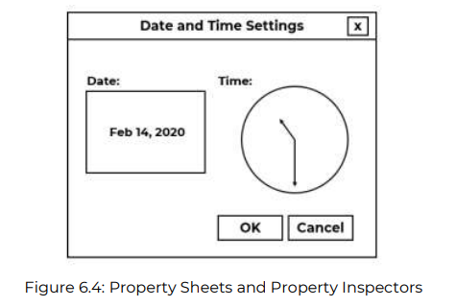

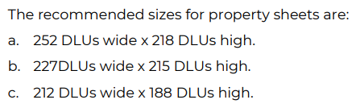

5. Message Boxes

- It is used to display a message about a particular situation or condition.

- It includes buttons like Ok, Cancel, Save, Help, Yes, No, etc.

- The title box also includes a close button.

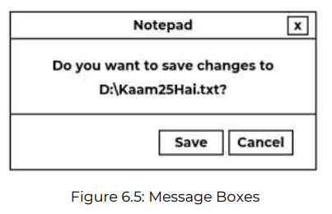

6. Palette Windows

- A palette window contains a set of controls.

- It is distinguished by its visual appearance, a collection of images, colors or patterns.

- The title bar is shorter and it includes only a close button.

7. Pop-Up Windows

- It is a type of window which is not directly visible but appears when the user right clicks on a certain application or even just screen.

- It includes information about various actions that can be taken for example Refresh, Personalize, Close, Properties, etc.

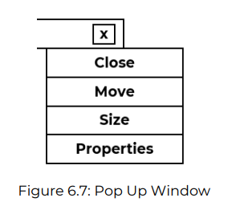

***Windows Presentation Styles***

The presentation style of window refers to its spatial relationship to other windows.

Types :

1. Tiles Windows

- The name derives from common floor or wall tile.

- It appears in one plane on the screen and covers the screen space.

- It provides two-dimensional tiled windows, adjustable in both height and width.

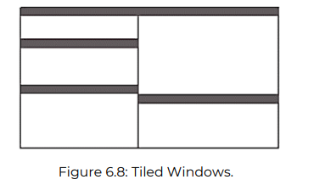

Advantages :

* The windows are positioned automatically.
* It is always visible and can’t get lost behind other windows.
* No information is hidden since all windows are visible.
* The user can easily multitask with this type of window.

Disadvantages :

* Only a limited amount of windows can be opened at once.
* Too much of windows can lead to reduction of other window sizes

2. Overlapping Windows :

It is a type of window in which one window can be placed on top of another window. It posses a three-dimensional quality in plant. The location as well as the plane is user controlled.

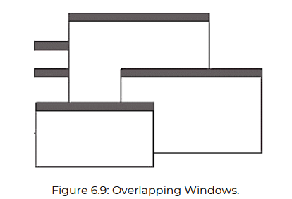

Adv :

* The user can move one window to another location.
* The user can choose which windows require large size and which small.
* They yield better results in task.

Dis :

* Since the windows overlap the information of one window is hidden by another window.
* Too many windows can be visually overwhelming.
* It requires more attention from the user.

3. Cascading Windows

It is a special type of overlapping windows. In this the windows are arranged in regular progression to each other. The front window is present and its information very visible but for the rest of the windows in most cases only their title bars are visible.

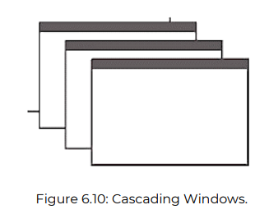

Adv :

* Bringing any window to the front is easier
* It provides simplicity in visual presentation and cleanness.

Disadv :

* Having too many windows open is not good for task handling

***Menus***

* Menu is a graphical element which consists of list of elements that can be accessed by clicking on a certain item.
* The list can include different commands or shortcut keys or action to perform.

Types of Menus :

1. Menu Bar :

A menu bar is a graphical control element which consists of various items arranged in horizontal fashion. Each item has a drop-down menu option.

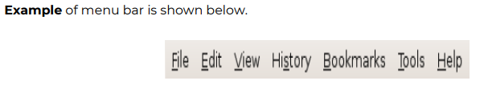

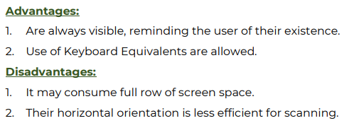

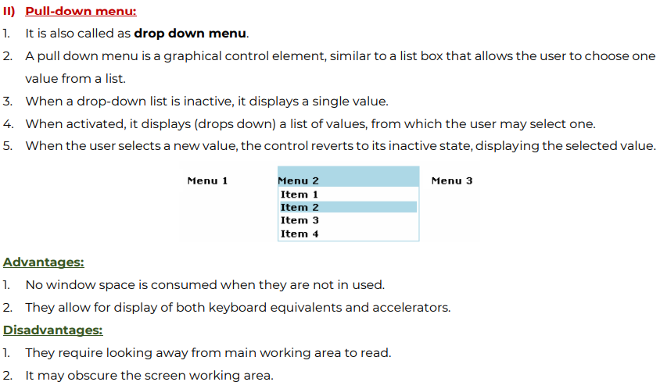

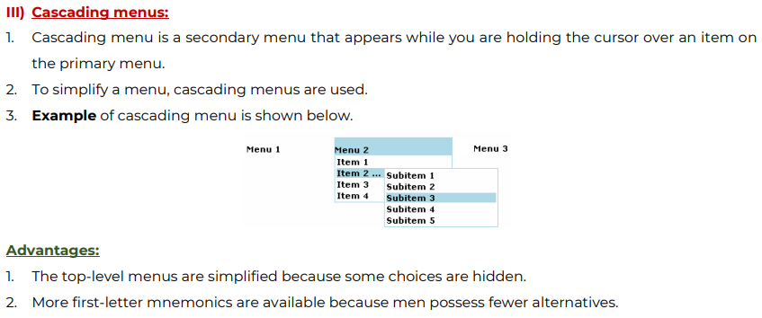

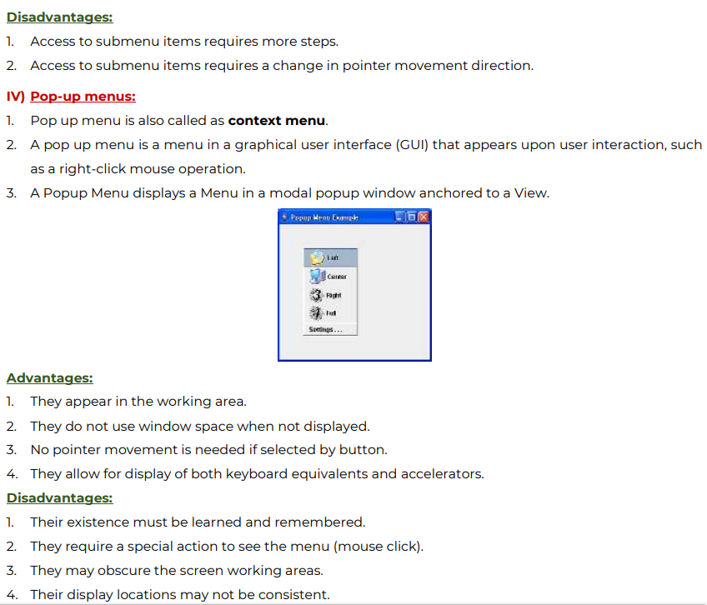

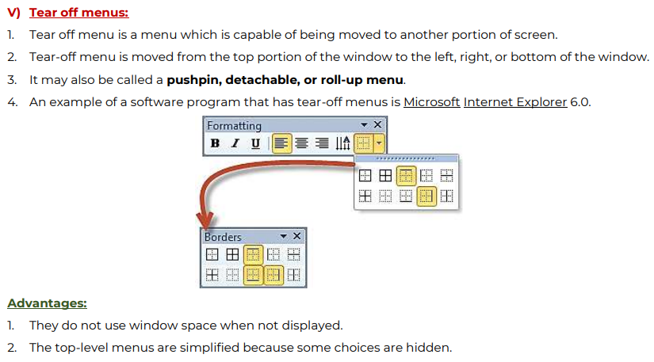

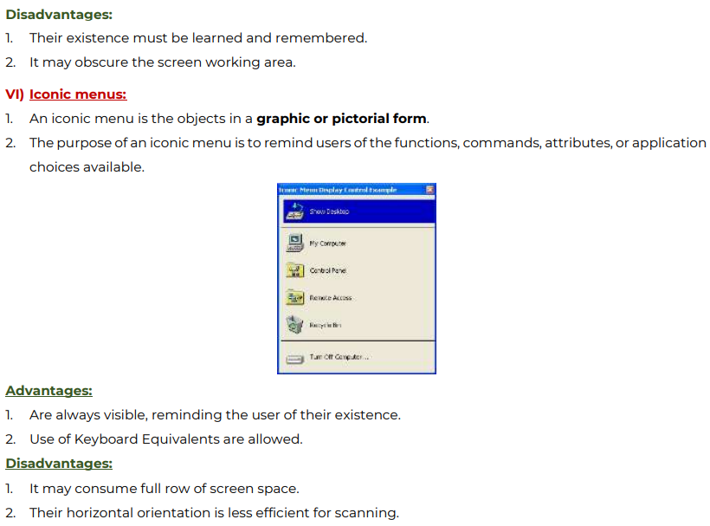

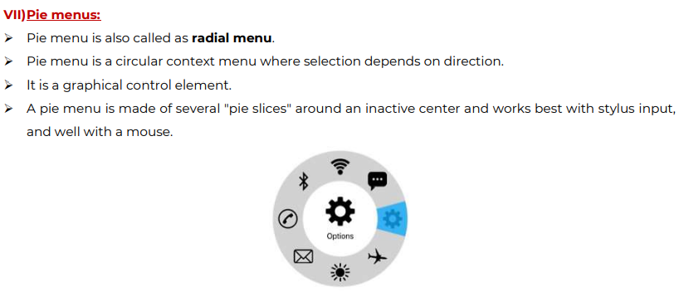

Module 06 : Interaction Styles and Communication

Explain importance of text messages with respect to communication with users

Short note on icons

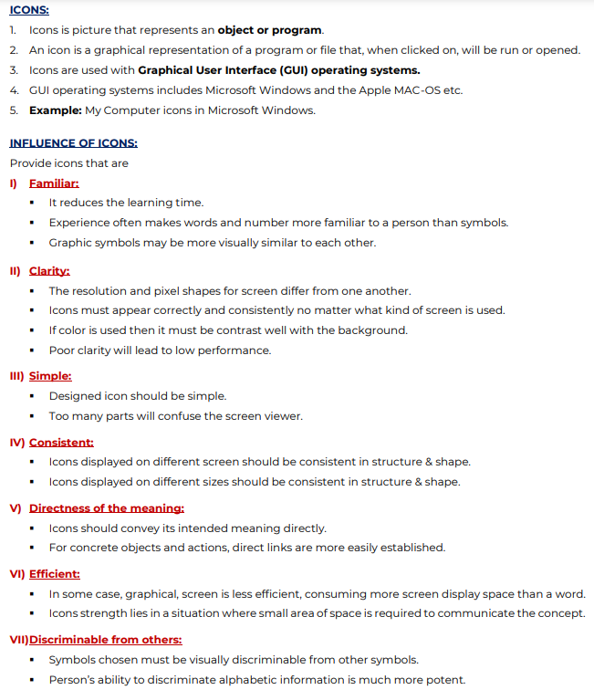

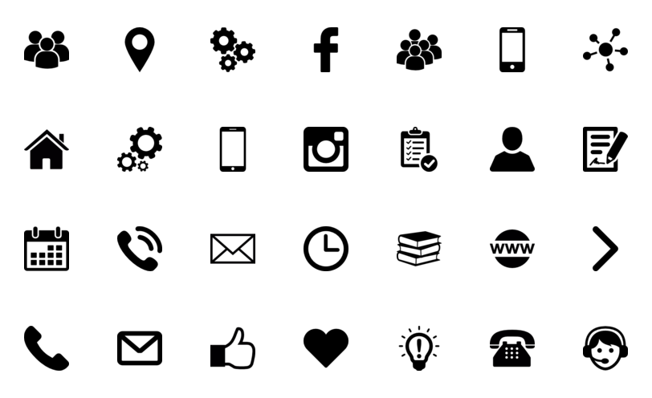

***Guidelines for color selection for web pages***

<https://www.flux-academy.com/blog/ultimate-guide-to-choosing-colors-for-web-design>

***Response time. Methodologies Adopted for Feedback and Guidance.***

Response time is generally defined as the duration of time needed by the system to express state changes to the user. In general, short durations and instantaneous response times are desirable. Instantaneous means that the user perceives system reactions as immediate. But even in situations in which an instantaneous response cannot be obtained, there must be some indication to the user that the system has received the request for action and is working on a response.

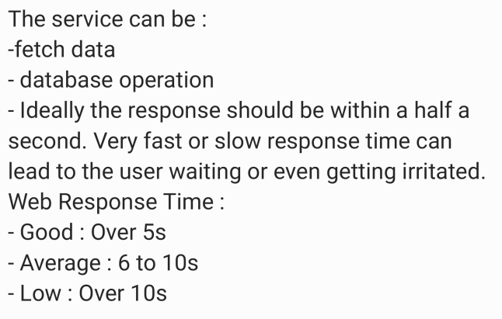

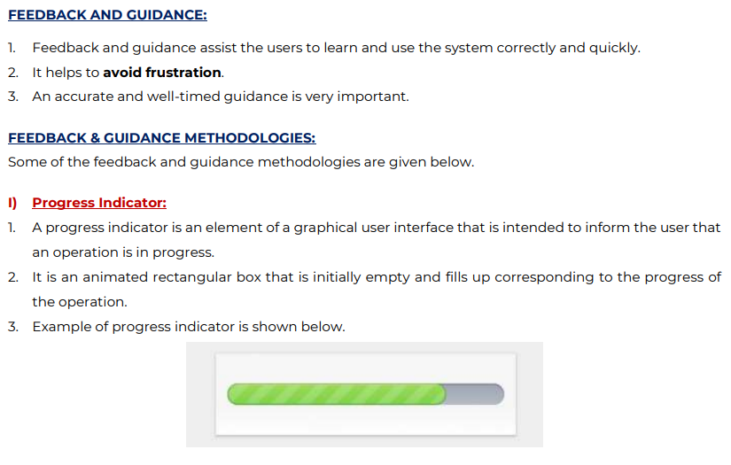

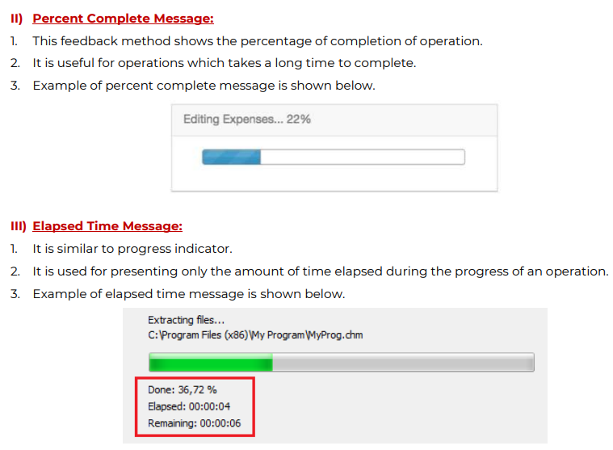

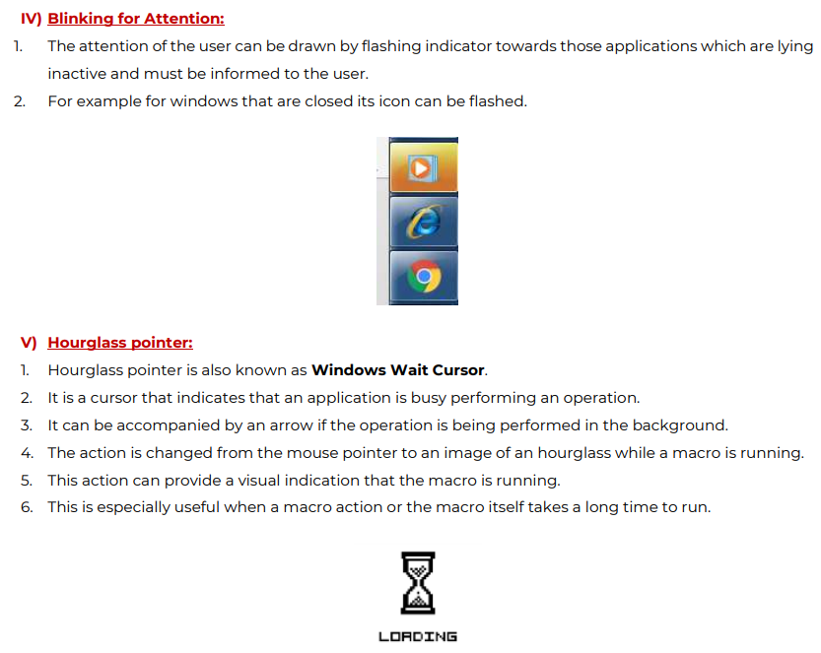

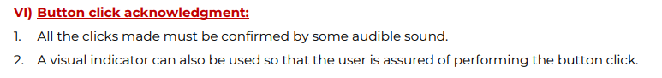

Graphics icons and images

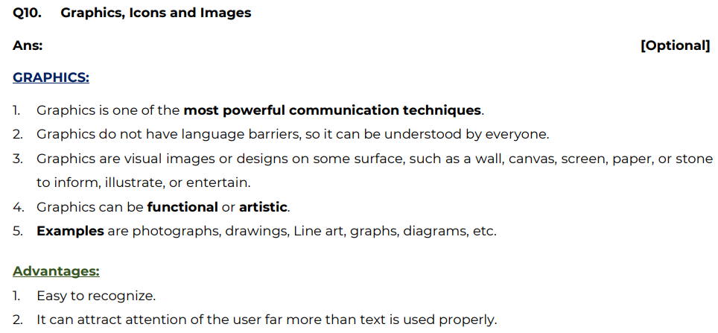

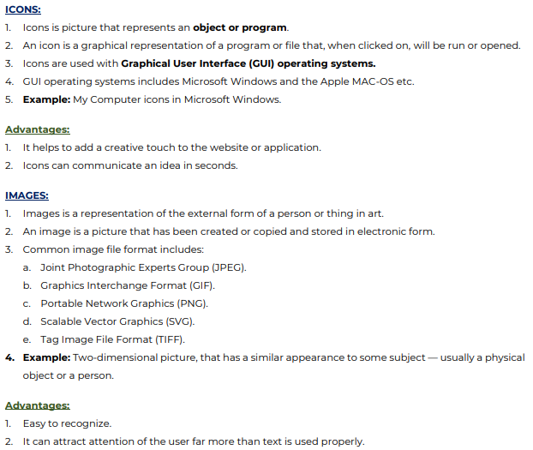

Design Web

* Design a user interface for a ‘Save Water’ campaign. Assume appropriate data required for it.
* Design a user interface of Career Guidance for 12th standard students. It should give information about various fields available, eligibility criteria, future scope, fees etc.
* Design a user interface for a ‘Save Girl Child’ awareness campaign. Assume appropriate data required for it.
* Design the web user interface of a monthly expense tracker. Assume suitable data and draw interfaces neatly.
* State Electricity Distribution Company wants to provide self help portal for its customers. The portal consists of online meter logging facility, Bill Payments, VDS i.e. Voluntary Deposit Scheme for Bill. Complaint and other Facilities. Being a Subject Matter Expert (SME) provide the detailed analysis along with interface that will be used by people in all Districts.
* Design a user interface for a ‘Save Earth’ awareness campaign. Assume appropriate data required for it.
* Design the web user interface of a vacation planner. Assume suitable data and draw interfaces neatly.
* Design a user interface to spread awareness about ‘Clean India….Green India’
* List pros and cons of any one modern device in design of a tutor for kids.

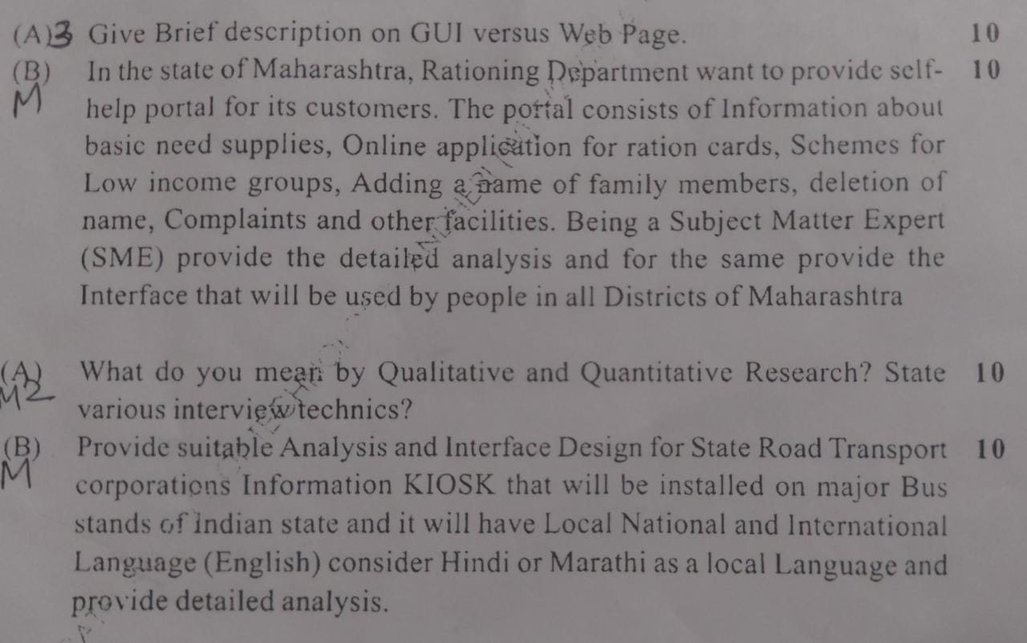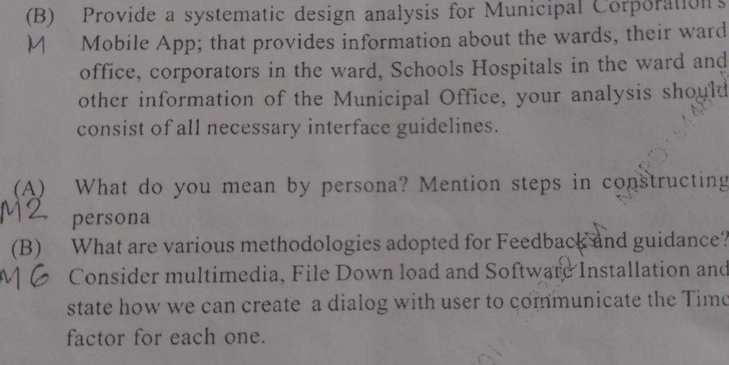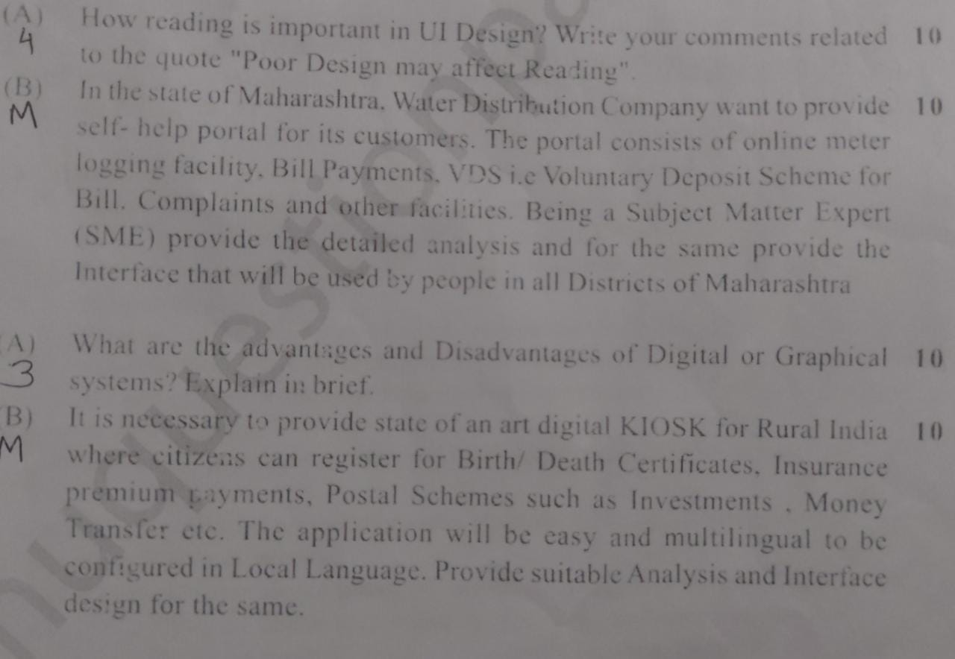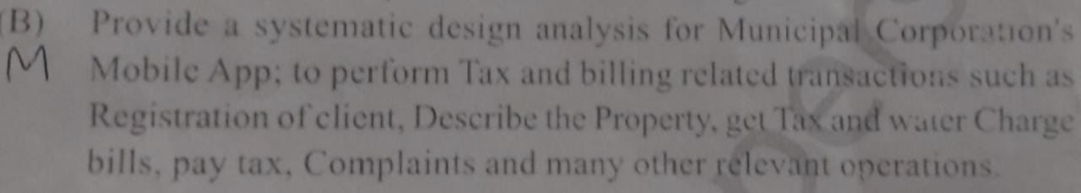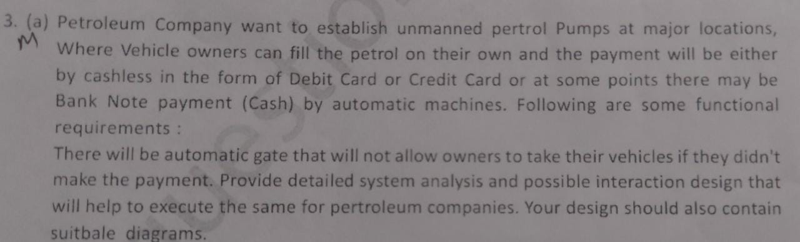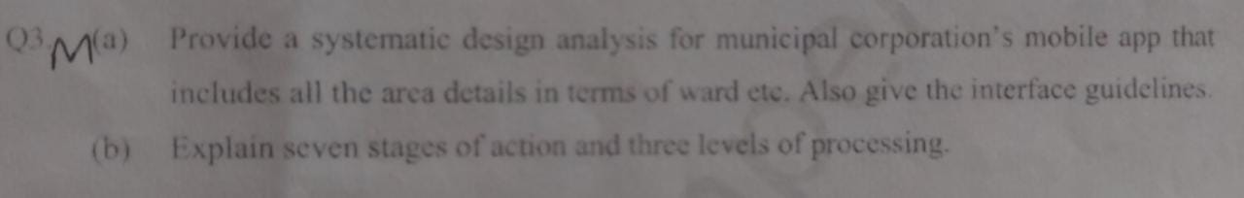

Provide suitable analysis and interface design for state road transportation system

